# Publish Data To Thingsboard from Command Prompt

You can post data to ThingsBoard using Windows Command Prompt by follwing steps:

**Step 1:** Go to CommandPrompt

**Step 2**: Install curl

**Step 3**: For https protocol, execute following command

curl -v -X POST -d "{"temperature": 25}" $THINGSBOARD_HOST_NAME/api/v1/$ACCESS_TOKEN/telemetry --header "Content-Type:application/json"

$THINGSBOARD_HOST_NAME = <https://demo.thingsboard.io/> $ACCESS_TOKEN –

You can test the same by creating device on ThingsBoard demo version as follows:

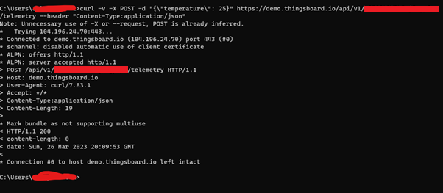

**Step 4**: For CoAP protocol, install aiocoap library using following command

pi install aiocoap

**Step 5**: Execute command in following format

echo -n '{"temperature": 25}' | coap post coap://demo.thingsboard.io/api/v1/ABC123/telemetry

